МИНИСТЕРСТВО НАУКИ И ВЫСШЕГО ОБРАЗОВАНИЯ РФ
ФГБОУ ВО
Московский авиационный институт
(национальный исследовательский университет)
Кафедра 304
Вычислительные машины, системы и сети

Отчет по лабораторной работе №6
по учебной дисциплине «Базы Данных»

Выполнил студент группы М3О-311Б-21:
Давыдов А.П.
Принял:
Ткачев О.А.
Мурсенков П.А.

Москва 2023

Задания к лабораторной работе
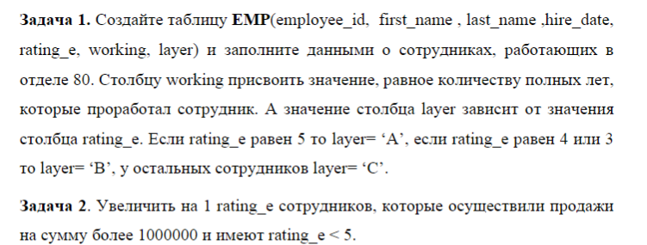
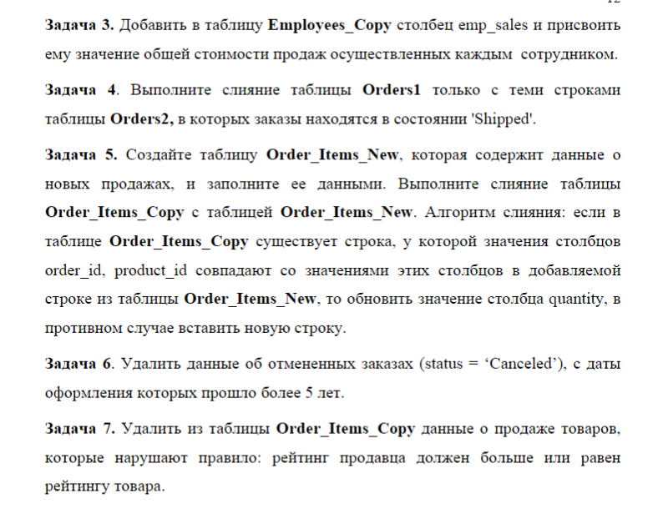
Выполнение
Задание 1
Условие:
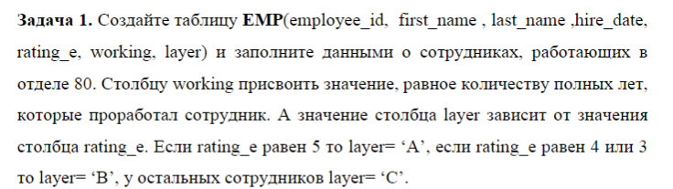
Запрос:
CREATE TABLE EMP AS
(
SELECT employee_id,
first_name,
last_name,
hire_date,
rating_e,
EXTRACT(YEAR FROM AGE(hire_date)) as working,
(
CASE
WHEN rating_e = 5 THEN 'A'
WHEN rating_e = 4 OR rating_e = 3 THEN 'B'
ELSE 'C'
END
) as layer
FROM hr_poc.employees WHERE department_id = 80
);
Вывод:
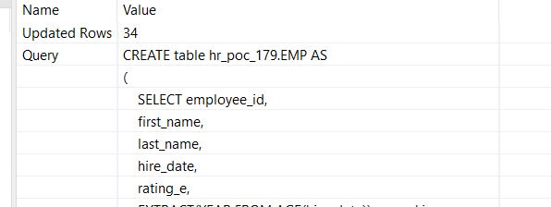

Задание 2
Условие:
Запрос:
UPDATE EMP o
SET rating_e = rating_e + 1
WHERE rating_e < 5
AND EXISTS
(SELECT salesman_id
FROM EMP o1
JOIN hr_poc_179.orders ON(salesman_id = employee_id)
JOIN hr_poc_179.order_items oi USING(order_id)
WHERE o.employee_id = o1.employee_id
AND status LIKE 'Shipped'
GROUP BY salesman_id
HAVING SUM(oi.quantity * oi.unit_price) > 1000000)
Вывод:
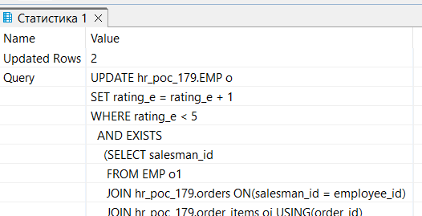

Задание 3
Условие:
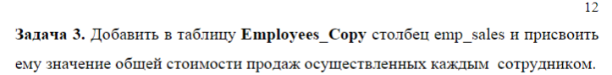
Запрос:
CREATE TABLE hr_poc_179.Employees_Copy AS
(SELECT *
FROM hr_poc_179.employees e
JOIN
(SELECT SUM(oi.quantity * oi.unit_price) AS emp_sales,
salesman_id AS employee_id
FROM hr_poc_179.employees e1
JOIN hr_poc_179.orders ON(salesman_id = employee_id)
JOIN hr_poc_179.order_items oi USING(order_id)
WHERE status LIKE 'Shipped'
GROUP BY salesman_id) AS e1 USING(employee_id))

Вывод:

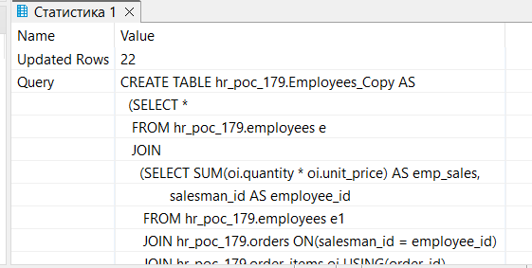

Задание 4
Условие:
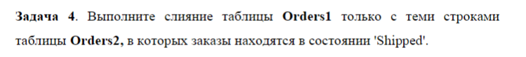
Запрос:
create table Orders2 as (
select *
from orders o
limit 50
)

create table Orders1 as (
select *
from orders o
offset 50
)

MERGE INTO Orders1 AS o1 USING
(SELECT *
FROM Orders2
WHERE status = 'Shipped') AS o2 ON (o1.order_id = o2.order_id) WHEN MATCHED THEN
UPDATE
SET status = o2.status WHEN NOT MATCHED THEN
INSERT (order_id,
customer_id,
status,
salesman_id,
order_date)
VALUES (o2.order_id, o2.customer_id, o2.status, o2.salesman_id, o2.order_date)

Вывод:

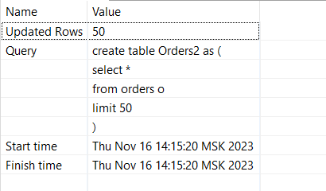
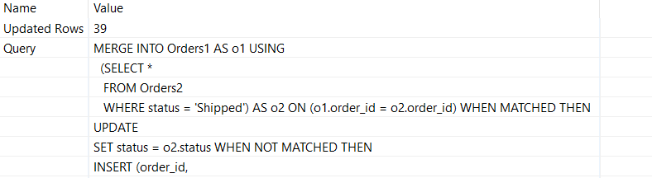

Задание 5
Условие:
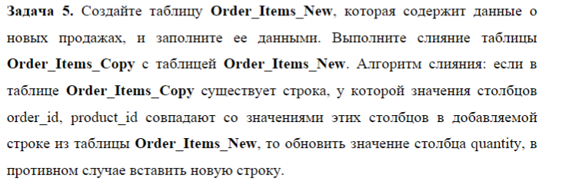
Запрос:
CREATE TABLE hr_poc_179.Order_Items_New (
order_id integer NOT NULL,
item_id integer NOT NULL,
product_id integer NOT NULL,
quantity integer NOT NULL,
unit_price numeric(10,2) NOT NULL
);

INSERT INTO hr_poc_179.Order_Items_New (order_id, item_id, product_id, quantity, unit_price) VALUES
(1, 13, 79, 30, 5600.00),
(2, 25, 25, 67, 2700.00),
(3, 4, 17, 67, 5700.00),
(4, 6, 28, 167, 7600.00),
(5, 10, 35, 76, 4600.00),
(6, 7, 60, 3, 1660.00),
(7, 5, 7, 1, 3600.00);
CREATE TABLE hr_poc_179.Order_Items_Copy AS (SELECT * FROM hr_poc_179.order_items);

MERGE INTO hr_poc_179.Order_Items_Copy AS t
USING hr_poc_179.Order_Items_New AS s
ON (t.order_id = s.order_id AND t.product_id = s.product_id)
WHEN MATCHED THEN
UPDATE SET quantity = s.quantity
WHEN NOT MATCHED THEN
INSERT (order_id, item_id, product_id, quantity, unit_price) VALUES (s.order_id, s.item_id, s.product_id, s.quantity, s.unit_price);

Вывод:
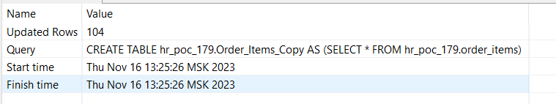

Задание 6
Условие:
Запрос:
DELETE FROM hr_poc_179.orders
WHERE status = 'Canceled' AND EXTRACT(YEAR FROM AGE(order_date)) > 5

Вывод:
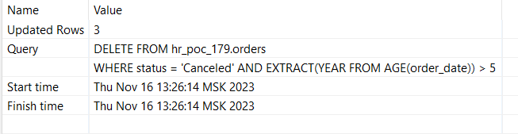
Задание 7
Условие:
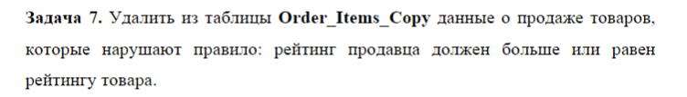
Запрос:
DELETE
FROM hr_poc_179.Order_Items_Copy o
WHERE (o.order_id,
o.item_id) IN
(SELECT order_id,
item_id
FROM
(SELECT order_id,
item_id,
rating_e
FROM Order_Items_Copy
JOIN hr_poc_179.orders USING(order_id)
JOIN hr_poc_179.employees ON(salesman_id = employee_id))
JOIN
(SELECT order_id,
item_id,
rating_p
FROM Order_Items_Copy
JOIN hr_poc_179.products USING(product_id)) USING(order_id,
item_id)
WHERE rating_e >= rating_p)
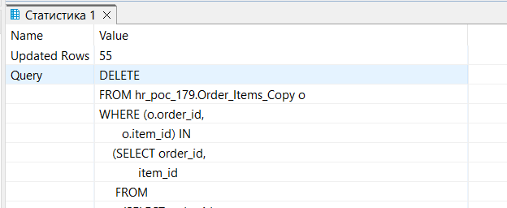
Вывод:

